|  |
| --- |
| Home |
| COMP2121 Project |
| User Manual |
|  |
| **Lewis Lee & Andrew Chan** |
| **[Pick the date]** |

|  |
| --- |
| This project involves developing and emulating system to emulate a lift door controller using an AVR Development Board. |

# User Manual

Usually, an elevator controller should control orders from numerous sources. These include internal floor select buttons, door control and external call buttons on each floor. The lift that will be emulated has a solitary call button on every floor, and floor select, emergency, open and close buttons inside the elevator.

# Getting Started

The first things you will need to do is connect the ports

LCD D0-D7 -> PC0-PC7

LCD BE-RS -> PA0-PA3

KEYPAD - PORTD

Motor - PB7

External interrupts- button 1 PE4, button 2 PE5

LED - PB0 - PB3

AUDIO ASD- PIN1, AIN - PB6

[INSERT IMAGE OF CONNECTIONS]

# Elevator Operations

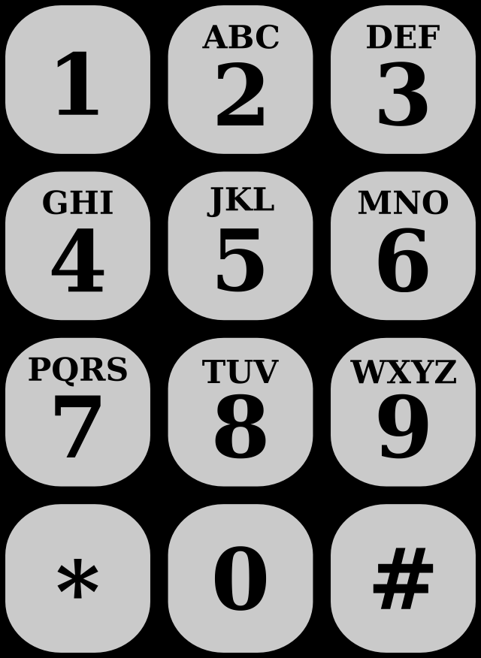

Hash key (#) = Open’s the elevator door’s

Button 0 = Closes the elevator door’s

Button 1 = Emergency button

Keys 0-9 request a floor

LCD displays current floor level